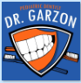
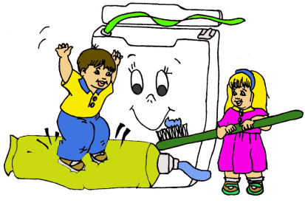
MARTHA GARZON, DMD, MS, PLLC
Pediatric and Adolescent Dentistry
870 South Kelly Avenue, Edmond, OK 73003
Phone: (405) 348- 5757 Fax (405) 348-8221
______________________________________________________________________________

SEDATION AND GENERAL ANESTHESIA DISCHARGE INSTRUCTIONS FOLLOWING DENTAL RESTORATIONS

- Your child MUST be supervised by an adult for the remainder of the day. The effects of the medication will wear off slowly over several hours. Your child may sleep during this period or become very irritable- the response varies. Make sure he/ she is breathing normally (the chin should be tipped up, not down towards their chest).
Your child may play if desired, but should play quietly under your supervision.
- After treatment, follow the anesthesiologist's instructions. The first drink should be clear fluids. Small drinks taken frequently are preferable to taking large amounts. Soft food, not too hot, may be taken after the anesthesia wears off.
- Your child’s temperature may be elevated one or two degrees the first 24 hours after treatment. REGULAR, OVER THE COUNTER, PLAIN Motrin every 4 to 6 hours and fluids will help alleviate this condition.
- DO NOT GIVE YOUR CHILD ANY MEDICATIONS THAT CAUSE DROWSINESS UNLESS APPROVED BY THE DOCTOR. IF YOUR CHILD IS SORE, REGULAR OR PLAIN MOTRIN IS RECOMMENDED.
- Your child has received a local anesthetic (or sleepy juice), so their teeth can take a nap. This medicine often “numbs” the area or the mouth where the teeth were treated. Assure your child (if they ask) that the teeth will wake up in 2- 4 hours. Please watch your child and make sure he/she is not biting, pinching, or sucking their cheek, lips, or tongue.
- If primary or permanent teeth were extracted, apply biting pressure with gauze to the extraction site until bleeding stops- usually 30 minutes to 1 hour. Change the gauze as needed. Your child should not drink carbonated beverages and should NOT USE STRAWS for the first 48 hours after extractions.
- Normal diet, activities, and oral hygiene may be resumed the day following treatment. In general, it is important that your child does not chew hard or sticky candies after dental restorations are placed on his teeth.
- Your child may feel dizzy or sleepy for the next 24 hours. He/she may have a sore throat and muscle aches..
- SEEK ADVICE IF:
  - Nausea and vomiting persist beyond 4 to 6 hours.
  - Temperature remains elevated beyond 24 hours or goes above 101°F
  - If there is any difficulty breathing or poor coloration of the child.
  - Other matters that cause your concern.
- Please call our office if you have questions or concerns. If you call after business hours, you will hear a message with instructions on how to reach Dr. Garzon.

